Have you ever visited a Web site on Google and immediately left after clicking on the link? Generally speaking, when people visit a Web site, if they do not find what they are looking for within a short span of time, they leave. It is a small window, and one of the ways to leverage that critical moment is by enhancing the visual appeal of the site. Moreover, an aesthetically pleasing Web site is not only more alluring, but it also tends to make navigation easier (increasing the likelihood of the end user being successful in his or her search). This is where CSS becomes important.
Through CSS, it is possible to create beautiful Web-site designs that span across as many of your Web site’s Web pages as you need. Not only that, but changing aspects of those designs—even on 100-plus pages on your site—only requires changing one external CSS file. Of course, that is your end goal. For this Discussion, you will complete a simpler task: the modification and recreation of the following table in CSS, using NetBeans:
Module Name | Computer Structures
Aim | To provide a comprehensive overview of core software and hardware technologies
Description | This Module covers everything from computer architecture to databases, algorithms, languages, operating systems, communications, computer networks, artificial intelligence and the theoretical foundations of computation. By studying this module, you will gain a sound theoretical and practical grounding on which to build your understanding of future technical developments.
Modality | 100% Online
Topics | Foundation, Machine Architecture, Software, Data Organisation, Artificial Intelligence
An example of your expected results is shown.
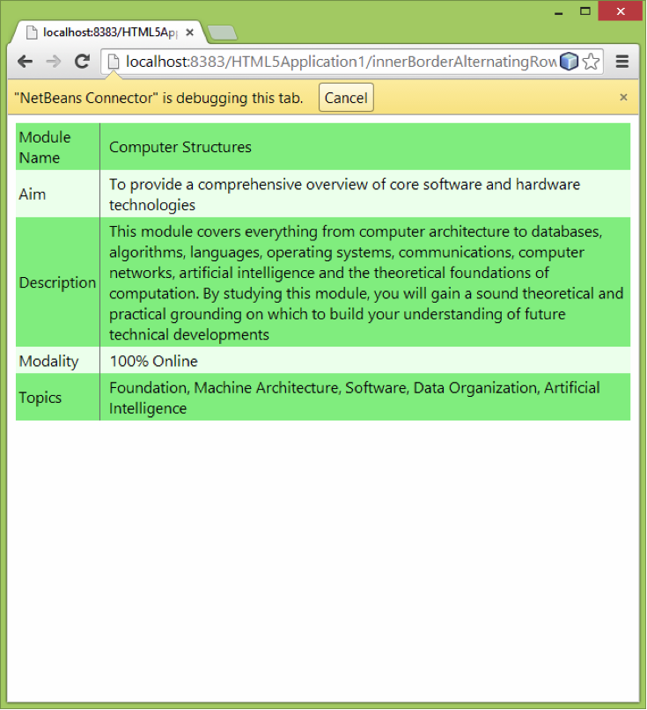
To complete this Discussion:
Post: Create an initial post in which you present your application’s code and results. To do this, use NetBeans IDE to design, develop and test an HTML file named innerBorderAlternatingRowsWithCSS.html. Your file must display the given two-column table and all its information and should resemble the example image. Using CSS, your table must also meet the following style criteria:
- Display an inner border line in the middle of the table, between the left column and the right column.
- The table rows should show alternating colours.
When you are finished, post screenshots of your work that include both your code and results and then explain the methods you used in order to complete your application.

